**ONLINE BANKNG SYSTEM**

**AIM:**

To design Online Banking System using HTML, CSS, JAVA SCRIPT, and PHP.

**ABSTRACT:**

Online Banking System is primarily designed for online banking for balance inquiry, transfer of funds to anther account in the same bank, loan information. The main objective of the Online Banking System is to manage the details of the Accounts. The purpose of the project is to build an application program to reduce the manual work for managing the accounts of the customer. It tracks all the details about the Transactions, Balance.

**INTRODUCTION:**

Banking activities are considered to be the life blood of the national Economy. Without banking services, trading and business activities cannot be carried on smoothly. Banks are the distributors and protectors of liquid capital which is of vital significance to a developing country. Efficient administration of the banking system helps in the economic Growth of the nation. Banking is useful to trade and commerce.

Online Banking is one of the most important financial activities which will be carried out by any person who holds a bank account. There are various activities that can be carried out once you log in to your bank account. Once a user logs in he or she can check the bank balance, check bank account transaction history or account summary, add beneficiary accounts, transfer funds to another account, download account summary. Whenever we deal with a banking system main concern should be the security related to banking transactions and account login activity.

**EXECUTION PROCEDURE:**

HOME: This page is a home page. Users can view the details about the bank and can access the login, signup and contact page. This page acts an introduction to the user about the bank.

LOGIN: This is the login page. Here the user can login into an existing account and profile data. The user can only view the details by logging into and existing profile or account.

SIGNUP: This is signup page. Here the user can create an account and login into the preceding account details. By registering the user creates a new profile in the bank.

ACCOUNT SUMMARY: This is the account profile page. Here the user can view the data regarding account details and can navigate through the options available .

TRANSACTION DETAILS: Here we can see the details regarding the last transactions of the user and accunt details.

TRANSFER: This is the payment or transfer page . Here the user can send the amount by entering the details required.

LOGOUT: By logging out, the user can leave the profile data and can be redirected to the home page. After this user can login and can see his account profile.

**REQUIREMENTS:**

SOFTWARE INTERFACES

● Front End : HTML, Css, Javascript  
● Data Base : SQL Server 2005 / MySQL  
● Technology : Java and Framework

HARDWARE INTERFACES

● Hard disk : 80GB Min.  
● RAM : 2 GB Min. & Above  
● Processor : Intel Pentium-IV and above

**Account.php**

<?php

session_start();

include("connection.php");

$userprofile = $_SESSION['user_name'];

if($userprofile == true)

{

} else

{

header('location:login.php');

}

$query = "SELECT * FROM user where name='$userprofile'";

$data = mysqli_query($conn,$query);

$result = mysqli_fetch_assoc($data);

?>

<!DOCTYPE html>

<html lang="en">

<head>

<meta charset="UTF-8">

<meta name="viewport" content="width=device-width, initial-scale=1.0">

<link rel="stylesheet" href="https://cdnjs.cloudflare.com/ajax/libs/font-awesome/5.15.1/css/all.min.css" integrity="sha512-+4zCK9k+qNFUR5X+cKL9EIR+ZOhtIloNl9GIKS57V1MyNsYpYcUrUeQc9vNfzsWfV28IaLL3i96P9sdNyeRssA==" crossorigin="anonymous" />

<link rel="stylesheet" href="css/style2.css">

<title>BON | HOME</title>

</head>

<body>

<!-- NavBar -->

<ul style=" background-color: #1d0f00;padding:20px 0;">

<li><a><i class="fas fa-hand-holding-usd"></i> BANK OF NIRVANA&nbsp;&nbsp;&nbsp;&nbsp;</a></li>

<li><a href="accounts.php">Account Summary</a></li>

<li><a href="transactions.php">Transactions</a></li>

<li><a href="transfer.php">Transfer</a></li>

<li style="float:right"><a class="activered" href="logout.php">Log Out</a></li>

<li style="float:right"><a class="activeblue" href="">Account Balance: Rs. <?php echo $result['balance'];?> </a></li>

</ul>

<!-- NavBar -->

<div class="accbody">

<div class="header">

<h3 style="font-size: 1.2rem;text-align: center; padding-top: 10px; color: white;">Your account Information:</h3>

</div>

<table>

<div class="accbd" >

<div class="darklight">

<p>Account No: <?php echo $result['accno'];?></p>

</div>

<div class="dark ">

<p>Holder Name: <?php echo $result['name'];?></p>

</div>

<div class="darklight">

<p>Balance : Rs.<?php echo $result['balance'];?></p>

</div>

<div class="dark">

<p>Email : <?php echo $result['email'];?></p>

</div>

<div class="darklight">

<p>Mobile No : <?php echo $result['phone'];?></p>

</div>

<div class="dark">

<p>Created On : <?php echo $result['timestamp'];?></p>

</div>

<div class="darklight">

<p>Branch Name:BANK OF NIRVANA</p>

</div>

<div class="dark">

<p>Branch Location: Andhra University</p>

</div>

</div>

</table>

</div>

</body>

</html>

**Cards.php**

<!DOCTYPE html>

<html lang="en">

<head>

<meta charset="UTF-8">

<meta http-equiv="X-UA-Compatible" content="IE=edge">

<meta name="viewport" content="width=device-width, initial-scale=1.0">

<title>BON | CARDS</title>

<script src="https://code.jquery.com/jquery-2.1.3.min.js"></script>

<link rel="stylesheet" href="https://stackpath.bootstrapcdn.com/bootstrap/4.2.1/css/bootstrap.min.css" integrity="sha384-GJzZqFGwb1QTTN6wy59ffF1BuGJpLSa9DkKMp0DgiMDm4iYMj70gZWKYbI706tWS" crossorigin="anonymous">

<script src="https://stackpath.bootstrapcdn.com/bootstrap/4.2.1/js/bootstrap.min.js" integrity="sha384-B0UglyR+jN6CkvvICOB2joaf5I4l3gm9GU6Hc1og6Ls7i6U/mkkaduKaBhlAXv9k" crossorigin="anonymous"></script>

<script defer src="https://use.fontawesome.com/releases/v5.0.13/js/all.js" integrity="sha384-xymdQtn1n3lH2wcu0qhcdaOpQwyoarkgLVxC/wZ5q7h9gHtxICrpcaSUfygqZGOe" crossorigin="anonymous"></script>

<link rel="stylesheet" href="css/style1.css">

</head>

<body>

<nav class="navbar navbar-expand-md primaryHeader fixed-top ">

<a href="index.php"><h3 class=" bigheading px-3">BANK OF NIRVANA</h3></a>

<button type="button" class="navbar-toggler bg-light" data-toggle="collapse" data-target="#nav">

<span class="navbar-toggler-icon"></span>

</button>

<div class="collapse navbar-collapse justify-content-between" id="nav">

<ul class="navbar-nav">

<li class="nav-item" >

<a class="nav-link px-3" href="#">Loans</a>

</li>

<li class="nav-item">

<a class="nav-link px-3 " href="#">Net bankings</a>

</li>

<li class="nav-item">

<a class="nav-link px-3" href="#">Cards</a>

</li>

<li class="nav-item">

<a class="nav-link px-3" href="#">support</a>

</li>

</ul>

<ul style="padding-inline-start: 0px;">

<li class="nav-item">

<a href="login.php" class="nav-link px-3" >Log in</i></a>

</li>

</ul>

</div>

</nav><!-- end of nav -->

<div class="cmain">

<div class="container">

<div class="row" style="margin-top: 150px;">

<div class="col-sm">

<div class="card" style="width: 30rem;">

<img class="card-img-top" src="https://tse3.mm.bing.net/th?id=OIP.SnA72-ShCtbODB7Dx9z3vwHaEK&pid=Api&P=0&w=283&h=160" alt="Card image cap">

<div class="card-body">

<h5 class="card-title">Visa Classic</h5>

<p class="card-text">Some quick example text to build on the card title and make up the bulk of the card's content.</p>

<a href="#" class="btn btn-primary">Apply now</a>

</div>

</div>

</div>

<div class="col-sm">

<div class="card" style="width: 30rem;">

<img class="card-img-top" src="https://tse3.mm.bing.net/th?id=OIP.cryLG--NnsKqPcz2l8QBfgHaEK&pid=Api&P=0&w=279&h=158" alt="Card image cap">

<div class="card-body">

<h5 class="card-title">Visa gold</h5>

<p class="card-text">Some quick example text to build on the card title and make up the bulk of the card's content.</p>

<a href="#" class="btn btn-primary">Apply now </a>

</div>

</div>

</div>

</div>

<div class="row" style="margin: 150px 0;">

<div class="col-sm ">

<div class="card" style="width: 30rem;">

<img class="card-img-top" src="https://tse1.mm.bing.net/th?id=OIP._weF9zBqqOVrcnJGPLaosAHaE5&pid=Api&P=0&w=261&h=174" alt="Card image cap">

<div class="card-body" >

<h5 class="card-title">Visa Platinum</h5>

<p class="card-text">Some quick example text to build on the card title and make up the bulk of the card's content.</p>

<a href="#" class="btn btn-primary">Apply now</a></a>

</div>

</div>

</div>

<div class="col-sm">

<div class="card" style="width: 30rem;">

<img class="card-img-top" src="https://tse3.mm.bing.net/th?id=OIP.tHFRtoAFve53FN7D9MuhzQHaFS&pid=Api&P=0&w=253&h=182" alt="Card image cap">

<div class="card-body">

<h5 class="card-title">Visa diamond</h5>

<p class="card-text">Some quick example text to build on the card title and make up the bulk of the card's content.</p>

<a href="#" class="btn btn-primary">Apply now</a>

</div>

</div>

</div>

</div>

<center><div style="padding-bottom: 100px;">

<h3>Online application</h3>

<ol style="text-align: start;padding: 20px 0 100px 100px; line-height: 2;font-size: 1.2rem;">

<li> 1. Quick and easy online application, and get a response within minutes. </li>

<li> 2. Receive and return your contracts electronically to finalise your loan faster.</li>

<li>3. Upload your documents and keep track of your application at any time of the day or night with Loan Tracker.</li>

</ol>

<h3>You'll also enjoy</h3>

<ol style="text-align: start;padding: 20px 0 0 100px; line-height: 2;font-size: 1.2rem;">

<li>1. Interest free days - up to 45 days interest free on purchases. </li>

<li> 2. Receive and return your contracts electronically to finalise your loan faster.</li>

<li>3. Upload your documents and keep track of your application at any time of the day or night with Loan Tracker.</li>

</ol>

</div></center>

</div>

</div>

<footer>

<div class="footer ">

<div id=media class="footercols">

<ul>

<li><a href="#"> Sitemap</a> </li>

<li><a href="#"> Legal Disclaimer</a> </li>

<li><a href="#"> Privacy Policy</a> </li>

<li><a href="#"> Legal Disclaimer</a> </li>

<li><a href="#"> Security Center </a> </li>

<li><a href="#">

Cookies Policy</a> </li>

</ul>

</div>

<div class="footercols ">

<ul>

<li><a href="#">resources</a></li>

<li><a href="#"> Accessibility</a> </li>

<li><a href="#">Faq</a> </li>

<li><a href="#">terms</a> </li>

<li><a href="#">Privacy</a> </li>

<li><a href="#">terms</a> </li>

<li><a href="#">Privacy</a> </li>

</ul>

</div>

<div class="footercols">

<ul>

<li><a href="#"> Sitemap</a> </li>

<li><a href="#"> Legal Disclaimer</a> </li>

<li><a href="#"> Privacy Policy</a> </li>

<li><a href="#"> Legal Disclaimer</a> </li>

<li><a href="#"> Security Center </a> </li>

</ul>

</div>

<div class="footercols ">

<ul>

<li><a href="">Company</a></li>

<li><a href="#">About us</a> </li>

<li><a href="#">contact us</a> </li>

<li><a href="#">Support chat</a> </li>

<li><a href="#">Gift membership</a> </li>

</ul>

</div>

</div>

</footer>

</body>

</html>

**Connection.php**

<?php

$servername = "localhost";

$username = "root";

$password = "";

$dbname = "itbank";

$conn = mysqli_connect($servername,$username,$password,$dbname);

if(!$conn){

die("Connection Failed because ".mysqli_connect_error());

}

?>

**Digital.php**

<!DOCTYPE html>

<html lang="en">

<head>

<meta charset="UTF-8">

<meta http-equiv="X-UA-Compatible" content="IE=edge">

<meta name="viewport" content="width=device-width, initial-scale=1.0">

<title>BON | netbankings</title>

<link rel="stylesheet" href="https://stackpath.bootstrapcdn.com/bootstrap/4.2.1/css/bootstrap.min.css" integrity="sha384-GJzZqFGwb1QTTN6wy59ffF1BuGJpLSa9DkKMp0DgiMDm4iYMj70gZWKYbI706tWS" crossorigin="anonymous">

<script src="https://stackpath.bootstrapcdn.com/bootstrap/4.2.1/js/bootstrap.min.js" integrity="sha384-B0UglyR+jN6CkvvICOB2joaf5I4l3gm9GU6Hc1og6Ls7i6U/mkkaduKaBhlAXv9k" crossorigin="anonymous"></script>

<script defer src="https://use.fontawesome.com/releases/v5.0.13/js/all.js" integrity="sha384-xymdQtn1n3lH2wcu0qhcdaOpQwyoarkgLVxC/wZ5q7h9gHtxICrpcaSUfygqZGOe" crossorigin="anonymous"></script>

<link rel="stylesheet" href="css/style1.css">

</head>

<body>

<!-- navbar -->

<nav class="navbar navbar-expand-md primaryHeader fixed-top ">

<a href="index.php"><h3 class=" bigheading px-3">BANK OF NIRVANA</h3></a>

<button type="button" class="navbar-toggler bg-light" data-toggle="collapse" data-target="#nav">

<span class="navbar-toggler-icon"></span>

</button>

<div class="collapse navbar-collapse justify-content-between" id="nav">

<ul class="navbar-nav">

<li class="nav-item" >

<a class="nav-link px-3" href="loans.php">Loans</a>

</li>

<li class="nav-item">

<a class="nav-link px-3 " href="digital.php">Net bankings</a>

</li>

<li class="nav-item">

<a class="nav-link px-3" href="cards.php">Cards</a>

</li>

</ul>

<ul style="padding-inline-start: 0px;">

<li class="nav-item">

<a href="login.php" class="nav-link px-3" >Log in</i></a>

</li>

</ul>

</div>

</nav><!-- end of nav -->

<section class="banking pt-5" style="margin-top: 100px;">

<div class="container">

<div class="row banking_grids text-center mt-lg-5 mt-sm-3">

<div class="col-md-4 grid1 mb-5">

<img src="https://tse2.mm.bing.net/th?id=OIP.pb7EtG3wunELjNeNX7Oj_QHaFj&pid=Api&P=0&w=212&h=159" alt="" class="img-fluid">

<h3 class="my-3">Mobile App</h3>

<p class=""> Vestibulum ante ipsum primis in faucibus orci luctus eted ultrices posuere Curae primis in faucibus orci luctus eted.</p>

</div>

<div class="col-md-4 grid2 mb-5">

<img src="https://tse2.mm.bing.net/th?id=OIP.8auYc2L4syYEOjerD9kT8gAAAA&pid=Api&P=0&w=239&h=180" alt="" class="img-fluid">

<h3 class="my-3">Instant Digital cards</h3>

<p class=""> Vestibulum ante ipsum primis in faucibus orci luctus et ultrices posuere Nulla in mollis dapibusedi nunc, turpis.</p>

</div>

<div class="col-md-4 grid3 mb-5">

<img src="https://tse2.mm.bing.net/th?id=OIP.Osj5BOI5QXlw-kxdmrncQAHaD6&pid=Api&P=0&w=298&h=158" alt="" class="img-fluid">

<h3 class="my-3">Card controls</h3>

<p class=""> Vestibulum ante ipsum primis in faucibus orci luctus eted ultrices posuere Curae primis in faucibus orci luctus eted.</p>

</div>

</div>

</div>

<div class="container">

<div class="row banking_grids text-center mt-lg-5 mt-sm-3">

<div class="col-md-4 grid1 mb-5">

<img src="https://tse4.mm.bing.net/th?id=OIP.R-W-JqpbUKw2TPf8YwbnAwHaE8&pid=Api&P=0&w=268&h=180" alt="" class="img-fluid">

<h3 class="my-3">Online banking</h3>

<p class=""> Vestibulum ante ipsum primis in faucibus orci luctus eted ultrices posuere Curae primis in faucibus orci luctus eted.</p>

</div>

<div class="col-md-4 grid2 mb-5">

<img src="https://tse4.mm.bing.net/th?id=OIP.k6F60hbhgotiTcR28jSsnwHaFj&pid=Api&P=0&w=204&h=154" alt="" class="img-fluid">

<h3 class="my-3">Instant Digital cards</h3>

<p class=""> Vestibulum ante ipsum primis in faucibus orci luctus et ultrices posuere Nulla in mollis dapibusedi nunc, turpis.</p>

</div>

<div class="col-md-4 grid3 mb-5">

<img src="https://tse3.mm.bing.net/th?id=OIP.JC1lnPbPYJ7zDrBF7PSmvgHaHa&pid=Api&P=0&w=300&h=300" alt="" class="img-fluid">

<h3 class="my-3">Card controls</h3>

<p class=""> Vestibulum ante ipsum primis in faucibus orci luctus eted ultrices posuere Curae primis in faucibus orci luctus eted.</p>

</div>

</div>

</div>

</section>

<footer>

<div class="footer ">

<div id=media class="footercols">

<ul>

<li><a href="#"> Sitemap</a> </li>

<li><a href="#"> Legal Disclaimer</a> </li>

<li><a href="#"> Privacy Policy</a> </li>

<li><a href="#"> Legal Disclaimer</a> </li>

<li><a href="#"> Security Center </a> </li>

<li><a href="#">

Cookies Policy</a> </li>

</ul>

</div>

<div class="footercols ">

<ul>

<li><a href="#">resources</a></li>

<li><a href="#"> Accessibility</a> </li>

<li><a href="#">Faq</a> </li>

<li><a href="#">terms</a> </li>

<li><a href="#">Privacy</a> </li>

<li><a href="#">terms</a> </li>

<li><a href="#">Privacy</a> </li>

</ul>

</div>

<div class="footercols">

<ul>

<li><a href="#"> Sitemap</a> </li>

<li><a href="#"> Legal Disclaimer</a> </li>

<li><a href="#"> Privacy Policy</a> </li>

<li><a href="#"> Legal Disclaimer</a> </li>

<li><a href="#"> Security Center </a> </li>

</ul>

</div>

<div class="footercols ">

<ul>

<li><a href="">Company</a></li>

<li><a href="#">About us</a> </li>

<li><a href="#">contact us</a> </li>

<li><a href="#">Support chat</a> </li>

<li><a href="#">Gift membership</a> </li>

</ul>

</div>

</div>

</footer>

</body>

</html>

**Index.php**

<!DOCTYPE html>

<html>

<head>

<!-- Required meta tags -->

<meta charset="utf-8">

<meta name="viewport" content="width=device-width, initial-scale=1.0">

<script src="https://code.jquery.com/jquery-2.1.3.min.js"></script>

<link rel="stylesheet" href="https://stackpath.bootstrapcdn.com/bootstrap/4.2.1/css/bootstrap.min.css" integrity="sha384-GJzZqFGwb1QTTN6wy59ffF1BuGJpLSa9DkKMp0DgiMDm4iYMj70gZWKYbI706tWS" crossorigin="anonymous">

<script src="https://stackpath.bootstrapcdn.com/bootstrap/4.2.1/js/bootstrap.min.js" integrity="sha384-B0UglyR+jN6CkvvICOB2joaf5I4l3gm9GU6Hc1og6Ls7i6U/mkkaduKaBhlAXv9k" crossorigin="anonymous"></script>

<script defer src="https://use.fontawesome.com/releases/v5.0.13/js/all.js" integrity="sha384-xymdQtn1n3lH2wcu0qhcdaOpQwyoarkgLVxC/wZ5q7h9gHtxICrpcaSUfygqZGOe" crossorigin="anonymous"></script>

<link rel="stylesheet" href="css/style1.css">

<!--This is used for search icon. Instead putting icon manually it is loaded from fontawesome-->

<title>Bank management system</title>

</head>

<body>

<!-- navbar -->

<nav class="navbar navbar-expand-md primaryHeader fixed-top ">

<a href="index.html"><h3 class=" bigheading px-3">BANK OF NIRVANA</h3></a>

<button type="button" class="navbar-toggler bg-light" data-toggle="collapse" data-target="#nav">

<span class="navbar-toggler-icon"></span>

</button>

<div class="collapse navbar-collapse justify-content-between" id="nav">

<ul class="navbar-nav">

<li class="nav-item" >

<a class="nav-link px-3" href="loans.php">Loans</a>

</li>

<li class="nav-item">

<a class="nav-link px-3 " href="digital.php">Net bankings</a>

</li>

<li class="nav-item">

<a class="nav-link px-3" href="cards.php">Cards</a>

</li>

<li class="nav-item">

<a class="nav-link px-3" href="support.php">support</a>

</li>

</ul>

<ul style="padding-inline-start: 0px;">

<li class="nav-item">

<a href="login.php" class="nav-link px-3" >Log in</i></a>

</li>

</ul>

</div>

</nav><!-- end of nav -->

<!-- <section2 -->

<div >

<div class="mainImg">

<h3>your bank at your finger tips</h3>

<button onclick="signup.php">signup now</button>

</div>

<div>

<!-- <section -->

<div class=" div3 container-fluiid">

<div class="row">

<div class="col-lg-9 bigheading ">

<h1>Fix your home loan worries with us</h1>

<h3>A no-frills home loan with a low variable rate from just 2.49%pa (comparison rate <span >2.49%pa</span>).</h3>

<button type="button" class="btn bt2 btn-primary btn-lg "><a href="loans.html" style="color: wheat;">Try it out now</a> </button>

</div>

<div class=" col-lg-3">

<img class="man-img" src="https://images.pexels.com/photos/3845344/pexels-photo-3845344.jpeg?auto=compress&cs=tinysrgb&dpr=1&w=280" alt="gamily-mockup">

</div>

</div>

</div>

<!-- <section3 -->

<center><h1><em><u>You choose ,we prove</u></em></h1></center>

<div class="section3">

<div class="features">

<div class="featurerow">

<img class="imgleft" src="https://images.pexels.com/photos/5790837/pexels-photo-5790837.jpeg?auto=compress&cs=tinysrgb&dpr=1&w=500" alt="paint-omg">

<div>

<i> <h3>Retirement looks different with nirvana</h3>

</i> <p class="p11">Use the funds for a range of purposes such as travel, a new car, home improvements, medical costs or living expenses.Lorem ipsum dolor sit amet, consectetur adipiscing elit, sed do eiusmod tempor incididunt ut labore et dolore magna aliqua. Blandit massa enim nec dui nunc mattis enim ut tellus. Egestas sed tempus urna et pharetra pharetra massa massa ultricies. Nulla pellentesque dignissim enim sit. Fringilla ut morbi tincidunt augue. Lobortis feugiat vivamus at augue eget arcu.</p>

</div>

</div>

<div class="featurerow">

<img class="imgright" src="https://images.pexels.com/photos/919436/pexels-photo-919436.jpeg?auto=compress&cs=tinysrgb&dpr=1&w=500" alt="">

<i> <h3>No card? No worries </h3> </i>

<p class="p12">It takes many hands to make life work. And no one gets that more than us.

With NIRVANA award-winning app, you can access and control the use of your card.Lorem ipsum dolor sit amet, consectetur adipiscing elit, sed do eiusmod tempor incididunt ut labore et dolore magna aliqua. Blandit massa enim nec dui nunc mattis enim ut tellus. Egestas sed tempus urna et pharetra pharetra massa massa ultricies. Nulla pellentesque dignissim enim sit. Fringilla ut morbi tincidunt augue. Lobortis feugiat vivamus at augue eget arcu.</p>

</div>

<div class="featurerow">

<img class="imgleft" src="https://images.pexels.com/photos/3799220/pexels-photo-3799220.jpeg?auto=compress&cs=tinysrgb&dpr=1&w=500" alt="">

<div>

<i><h3>Everyday bank accounts</h3></i>

<p class="p11">Our range of everyday transaction accounts have low fees, which means you get to keep more of your money for the things that matterLorem ipsum dolor sit amet, consectetur adipiscing elit, sed do eiusmod tempor incididunt ut labore et dolore magna aliqua. Blandit massa enim nec dui nunc mattis enim ut tellus. Egestas sed tempus urna et pharetra pharetra massa massa ultricies. Nulla pellentesque dignissim enim sit. Fringilla ut morbi tincidunt augue. Lobortis feugiat vivamus at augue eget arcu..</p>

</div>

</div>

<!-- <div class="featurerow">

<img class="imgright" src="https://images.pexels.com/photos/6289100/pexels-photo-6289100.jpeg?auto=compress&cs=tinysrgb&dpr=1&w=500" alt="">

<h3>Reverse Mortgage Home Loan</h3>

<p class="p12">A reverse mortgage for over 65s with a competitive variable interest rate for those wanting to access the equity in their home.Lorem ipsum dolor sit amet, consectetur adipiscing elit, sed do eiusmod tempor incididunt ut labore et dolore magna aliqua. Blandit massa enim nec dui nunc mattis enim ut tellus. Egestas sed tempus urna et pharetra pharetra massa massa ultricies. Nulla pellentesque dignissim enim sit. Fringilla ut morbi tincidunt augue. Lobortis feugiat vivamus at augue eget arcu.</p>

</div> -->

</div>

</div>

<footer>

<div class="footer ">

<div id=media class="footercols">

<ul>

<li><a href="#"> Sitemap</a> </li>

<li><a href="#"> Legal Disclaimer</a> </li>

<li><a href="#"> Privacy Policy</a> </li>

<li><a href="#"> Legal Disclaimer</a> </li>

<li><a href="#"> Security Center </a> </li>

<li><a href="#">

Cookies Policy</a> </li>

</ul>

</div>

<div class="footercols ">

<ul>

<li><a href="#">resources</a></li>

<li><a href="#"> Accessibility</a> </li>

<li><a href="#">Faq</a> </li>

<li><a href="#">terms</a> </li>

<li><a href="#">Privacy</a> </li>

<li><a href="#">terms</a> </li>

<li><a href="#">Privacy</a> </li>

</ul>

</div>

<div class="footercols">

<ul>

<li><a href="#"> Sitemap</a> </li>

<li><a href="#"> Legal Disclaimer</a> </li>

<li><a href="#"> Privacy Policy</a> </li>

<li><a href="#"> Legal Disclaimer</a> </li>

<li><a href="#"> Security Center </a> </li>

</ul>

</div>

<div class="footercols ">

<ul>

<li><a href="">Company</a></li>

<li><a href="#">About us</a> </li>

<li><a href="#">contact us</a> </li>

<li><a href="#">Support chat</a> </li>

<li><a href="#">Gift membership</a> </li>

</ul>

</div>

</div>

</footer>

</body>

</html>

**Loans.php**

<!DOCTYPE html>

<html lang="en">

<head>

<meta charset="UTF-8">

<meta http-equiv="X-UA-Compatible" content="IE=edge">

<meta name="viewport" content="width=device-width, initial-scale=1.0">

<title>BON | Loans</title>

<script src="https://code.jquery.com/jquery-2.1.3.min.js"></script>

<link rel="stylesheet" href="https://stackpath.bootstrapcdn.com/bootstrap/4.2.1/css/bootstrap.min.css" integrity="sha384-GJzZqFGwb1QTTN6wy59ffF1BuGJpLSa9DkKMp0DgiMDm4iYMj70gZWKYbI706tWS" crossorigin="anonymous">

<script src="https://stackpath.bootstrapcdn.com/bootstrap/4.2.1/js/bootstrap.min.js" integrity="sha384-B0UglyR+jN6CkvvICOB2joaf5I4l3gm9GU6Hc1og6Ls7i6U/mkkaduKaBhlAXv9k" crossorigin="anonymous"></script>

<script defer src="https://use.fontawesome.com/releases/v5.0.13/js/all.js" integrity="sha384-xymdQtn1n3lH2wcu0qhcdaOpQwyoarkgLVxC/wZ5q7h9gHtxICrpcaSUfygqZGOe" crossorigin="anonymous"></script>

<link rel="stylesheet" href="css/style1.css">

</head>

<body>

<nav class="navbar navbar-expand-md primaryHeader fixed-top ">

<a href="index.html"><h3 class=" bigheading px-3">BANK OF NIRVANA</h3></a>

<button type="button" class="navbar-toggler bg-light" data-toggle="collapse" data-target="#nav">

<span class="navbar-toggler-icon"></span>

</button>

<div class="collapse navbar-collapse justify-content-between" id="nav">

<ul class="navbar-nav">

<li class="nav-item" >

<a class="nav-link px-3" href="loans.php">Loans</a>

</li>

<li class="nav-item">

<a class="nav-link px-3 " href="digital.php">Net bankings</a>

</li>

<li class="nav-item">

<a class="nav-link px-3" href="cards.php">Cards</a>

</li>

<li class="nav-item">

<a class="nav-link px-3" href="support.php">support</a>

</li>

</ul>

<ul style="padding-inline-start: 0px;">

<li class="nav-item">

<a href="login.php" class="nav-link px-3" >Log in</i></a>

</li>

</ul>

</div>

</nav><!-- end of nav -->

<div class="loanMainImg">

<h3>Supporting those in need in our community</h3>

</div>

<!-- bbanner -->

<div class="banner" id="home">

<div class="layer">

<div class="container">

<div class="banner-text-w3pvt">

<!-- banner slider-->

<div class="csslider infinity" id="slider1">

<ul class="banner_slide_bg">

<li>

<div class="w3ls_banner_txt">

<h2 class="b-w3ltxt text-capitalize mt-md-4">Home <span>Loans.</span> </h2>

<h4 class="b-w3ltxt text-capitalize">Cash Management</h4>

<p class="w3ls_pvt-title my-3">onec consequat sapien ut leo cursus rhoncus. Nullam dui mi, vulputate ac metus semper Nullam dui mi.

Vestibulum ante ipsum primis in faucibus orci luctus et ultrices posuere cubiliacurae, Curabitur quis luctus lectus.

Morbi at dui nisl.Onec Consequat Sapien Ut Leo Cursus Rhoncus. Nullam Dui Mi, Vulputate Ac Metus Semper Nullam Dui Mi. Vestibulum Ante Ipsum Primis In Faucibus Orci Luctus Et Ultrices Posuere Cubiliacurae, Curabitur Quis Luctus Lectus. Morbi At Dui Nisl.</p>

<a href="services.html" class="btn btn-banner my-3 mr-2">Read More</a>

<a href="contact.html" class="btn btn-banner1 my-3">Get Started</a>

</div>

</li>

<li>

<div class="w3ls_banner_txt">

<h3 class="b-w3ltxt text-capitalize mt-md-4">Business <span>Loans</span> </h3>

<h4 class="b-w3ltxt text-capitalize">Cash Management</h4>

<p class="w3ls_pvt-title my-3">onec consequat sapien ut leo cursus rhoncus. Nullam dui mi, vulputate ac metus semper Nullam dui mi.

Vestibulum ante ipsum primis in faucibus orci luctus et ultrices posuere cubiliacurae, Curabitur quis luctus lectus.

Morbi at dui nisl.Onec Consequat Sapien Ut Leo Cursus Rhoncus. Nullam Dui Mi, Vulputate Ac Metus Semper Nullam Dui Mi. Vestibulum Ante Ipsum Primis In Faucibus Orci Luctus Et Ultrices Posuere Cubiliacurae, Curabitur Quis Luctus Lectus. Morbi At Dui Nisl.</p>

<a href="services.html" class="btn btn-banner my-3 mr-2">Read More</a>

<a href="contact.html" class="btn btn-banner1 my-3">Get Started</a>

</div>

</li>

<li>

<div class="w3ls_banner_txt">

<h3 class="b-w3ltxt text-capitalize mt-md-4">Commercial <span>Loans</span> </h3>

<h4 class="b-w3ltxt text-capitalize">Cash Management</h4>

<p class="w3ls_pvt-title my-3">onec consequat sapien ut leo cursus rhoncus.Onec Consequat Sapien Ut Leo Cursus Rhoncus. Nullam Dui Mi, Vulputate Ac Metus Semper Nullam Dui Mi. Vestibulum Ante Ipsum Primis In Faucibus Orci Luctus Et Ultrices Posuere Cubiliacurae, Curabitur Quis Luctus Lectus. Morbi At Dui Nisl. Nullam dui mi, vulputate ac metus semper Nullam dui mi.

Vestibulum ante ipsum primis in faucibus orci luctus et ultrices posuere cubiliacurae, Curabitur quis luctus lectus.

Morbi at dui nisl.</p>

<a href="services.html" class="btn btn-banner my-3 mr-2">Read More</a>

<a href="contact.html" class="btn btn-banner1 my-3">Get Started</a>

</div>

</li>

</ul>

</div>

<!-- //banner slider-->

</div>

</div>

</div>

</div>

<!-- //banner -->

<footer>

<div class="footer ">

<div id=media class="footercols">

<ul>

<li><a href="#"> Sitemap</a> </li>

<li><a href="#"> Legal Disclaimer</a> </li>

<li><a href="#"> Privacy Policy</a> </li>

<li><a href="#"> Legal Disclaimer</a> </li>

<li><a href="#"> Security Center </a> </li>

<li><a href="#">

Cookies Policy</a> </li>

</ul>

</div>

<div class="footercols ">

<ul>

<li><a href="#">resources</a></li>

<li><a href="#"> Accessibility</a> </li>

<li><a href="#">Faq</a> </li>

<li><a href="#">terms</a> </li>

<li><a href="#">Privacy</a> </li>

<li><a href="#">terms</a> </li>

<li><a href="#">Privacy</a> </li>

</ul>

</div>

<div class="footercols">

<ul>

<li><a href="#"> Sitemap</a> </li>

<li><a href="#"> Legal Disclaimer</a> </li>

<li><a href="#"> Privacy Policy</a> </li>

<li><a href="#"> Legal Disclaimer</a> </li>

<li><a href="#"> Security Center </a> </li>

</ul>

</div>

<div class="footercols ">

<ul>

<li><a href="">Company</a></li>

<li><a href="#">About us</a> </li>

<li><a href="#">contact us</a> </li>

<li><a href="#">Support chat</a> </li>

<li><a href="#">Gift membership</a> </li>

</ul>

</div>

</div>

</footer>

</body>

</html>

**Login.php**

<?php

session_start();

include("connection.php");

?>

<!DOCTYPE html>

<html lang="en">

<head>

<meta charset="UTF-8">

<meta name="viewport" content="width=device-width, initial-scale=1.0">

<title>BON | Login</title>

<link rel="stylesheet" href="css/style2.css">

</head>

<body>

<ul style=" background-color: #1d0f00;">

<li><a href="index.php" ><i class="fas fa-hand-holding-usd"></i><h2> BANK OF NIRVANA</h2>&nbsp;&nbsp;&nbsp;&nbsp;</a></li>

</ul>

<div class="signupDiv" style="height:70vh;">

<center style="border-bottom: 2px solid white;"><h1 class="head">Log In</h1></center>

<div class="formbody" style="border-top-right-radius:10px;">

<div style="margin-left: 11%;height: 40vh;text-align:center;margin-top:20px;width: 80%; background-color: beige;border-radius: 10px;">

<form action="" style="margin-left: -15px;margin-top: 20px;"class="formleft" method="post">

<input type="text" id="username" name="username" class="forminputtext" placeholder=" Enter your name">

<br>

<input type="password" id="pwd" name="password" class="forminputtext" placeholder=" Enter your Password">

<br>

<input type="submit" name="submit" class="acbtn" style=" background-color:hsl(32, 81%, 13%) ; color:white;width: 80%; margin-left: 20px; margin-top: 20px;" value="Login"></input>

<br>

<br>

<p>New here? Click <a href="signup.php">here</a> to register !</p>

</form>

</div>

</div>

</div>

</body>

</html>

<?php

if(isset($_POST['submit']))

{

$username = $_POST['username'];

$pwd = $_POST['password'];

$query = "SELECT * FROM user where name='$username' && password = '$pwd'";

$data = mysqli_query($conn,$query);

$total = mysqli_num_rows($data);

if($total == 1){

$_SESSION['user_name'] = $username;

header('location:accounts.php');

} else {

echo "<script></script>";

}

}

?>

**Logout.php**

<?php

session_start();

session_unset();

header('location:login.php');

?>

**Signup.php**

<?php include("connection.php") ?>

<!DOCTYPE html>

<html lang="en">

<head>

<meta charset="UTF-8">

<meta name="viewport" content="width=device-width, initial-scale=1.0">

<title>BON | SignUp</title>

<link rel="stylesheet" href="css/style2.css">

<script>

</script>

</head>

<body>

<ul style=" background-color: #1d0f00;">

<li ><a><i class="fas fa-hand-holding-usd"></i><h2> BANK OF NIRVANA</h2>&nbsp;&nbsp;&nbsp;&nbsp;</a></li>

</ul>

<div class="signupDiv" style ="height: 90vh;">

<center style="border-bottom: 2px solid white;"><h1 class="head">Sign Up</h1></center>

<div class="formbody">

<div class="signupleft" style="height: 415px;">

<form action="" class="formleft" method="">

<input type="text" id="accno" name="accno" class="forminputtext" minlength="6" placeholder=" Create your account no." required>

<br>

<input type="text" id="name" name="name" class="forminputtext" placeholder=" Enter your name" required>

<br>

<input type="text" id="phone" name="phone" class="forminputtext" placeholder=" Enter your mobile no." required>

<br>

<input type="text" id="email" name="email" class="forminputtext" placeholder=" Enter your email ID." required>

<br>

<input type="password" id="pwd" name="password" class="forminputtext" placeholder=" Enter your Password" required>

<br>

<input type="text" id="balance" name="balance" class="forminputtext" placeholder=" Enter your initial deposit." required>

<br>

<h3 class="forminputtext">Terms and Conditions:</h3>

<ul class="formdisplaytext">

<li>1. I am a citizen of India.</li>

<br>

<li>2. I am a student of Andhra University.</li>

</ul>

<input type="checkbox" id="terms" name="terms" class="forminputcheck">&nbsp;&nbsp;I agree to all the terms above.

<input type="submit" class="acbtn" name = "signup" style=" background-color:beige ; color:hsl(32, 81%, 13%);width: 80%; margin-left: 20px; margin-top: 20px;" value="signup"></input>

<br>

</form>

</div>

<div class="signupright" style="height: 415px;">

<h4 style="padding: 17px; color: whitesmoke; border: 1px solid black;">Already Have an account?</h4>

<h5 style="padding: 17px; text-align: center; border: 1px solid black; border-top: none;"><a href="login.php" style="text-decoration: none; color: white;">Click Here to Login !</a></h5>

</div>

</div>

</div>

<?php

error_reporting(0);

$accno = $_GET['accno'];

$name = $_GET['name'];

$phone = $_GET['phone'];

$email = $_GET['email'];

$pwd = $_GET['password'];

date_default_timezone_set('Asia/Kolkata');

$timestamp = $_SERVER['REQUEST_TIME'];

$createddate = date('F d,Y h:i:s A',$timestamp);

$bal = $_GET['balance'];

if($_GET['signup'] && $_GET['terms'] )

{

if($accno && $name && $phone && $email && $pwd && $bal){

$query = "INSERT INTO user VALUES('$accno','$name','$phone','$email','$pwd','$createddate','$bal')";

$data = mysqli_query($conn,$query);

if($data){

header('location:login.php');

}

}

else

{

echo "<script>alert('Please fill all the fields !');</script>";

}

} else {

echo "<script>alert('Please check the terms and conditions !');</script>";

}

?>

</body>

</html>

**Transactions.php**

<?php

session_start();

include("connection.php");

$userprofile = $_SESSION['user_name'];

if($userprofile == true)

{

} else

{

header('location:login.php');

}

$query = "SELECT * FROM user where name='$userprofile'";

$data = mysqli_query($conn,$query);

$result = mysqli_fetch_assoc($data);

$user_accno = $result['accno'];

$query2 = "SELECT * FROM transactions";

$transactionsdata = mysqli_query($conn,$query2);

$total = mysqli_num_rows($transactionsdata);

?>

<!DOCTYPE html>

<html lang="en">

<head>

<meta charset="UTF-8">

<meta name="viewport" content="width=device-width, initial-scale=1.0">

<link rel="stylesheet" href="https://cdnjs.cloudflare.com/ajax/libs/font-awesome/5.15.1/css/all.min.css" integrity="sha512-+4zCK9k+qNFUR5X+cKL9EIR+ZOhtIloNl9GIKS57V1MyNsYpYcUrUeQc9vNfzsWfV28IaLL3i96P9sdNyeRssA==" crossorigin="anonymous" />

<link rel="stylesheet" href="css/style2.css">

<title>BON | Transactions</title>

</head>

<body>

<!-- NavBar -->

<ul style="padding:20px 0;">

<li><a><i class="fas fa-hand-holding-usd"></i> BANK OF NIRVANA&nbsp;&nbsp;&nbsp;&nbsp;</a></li>

<li><a href="accounts.php">Account Summary</a></li>

<li><a href="transactions.php">Transactions</a></li>

<li><a href="transfer.php">Transfer</a></li>

<li style="float:right"><a class="activered" href="logout.php">Log Out</a></li>

<li style="float:right"><a class="activeblue" href="">Account Balance: Rs. <?php echo $result['balance'];?> </a></li>

</ul>

<!-- NavBar -->

<div class="accbody">

<div class="header">

<h3 style="font-size: 1.2rem;text-align: center; padding-top: 10px; color: white;">Your transactions :</h3>

</div>

<table>

<div class="accbd" style="overflow-y:scroll; height:400px;">

<?php

$i = 0;

while ($result2 = mysqli_fetch_assoc($transactionsdata)) {

$sender = $result2['sender_id'];

$receiver = $result2['receiver_id'];

if($user_accno == $sender || $user_accno == $receiver)

{

if($user_accno == $sender){

if($i++%2==0){

echo "<div class='dark'>

<p>Debited: &nbsp;Rs.".$result2['amount']." transferred to Acc. No: ".$result2['receiver_id'].".</p>

</div>";

} else {

echo "<div class='darklight'>

<p>Debited: &nbsp;Rs.".$result2['amount']." transferred to Acc. No: ".$result2['receiver_id'].".</p>

</div>";

}

}

else {

if($i++%2==0){

echo "<div class='dark'>

<p>Credited: &nbsp;Rs.".$result2['amount']." from Acc. No: ".$result2['receiver_id'].".</p>

</div>";

} else {

echo "<div class='darklight'>

<p>Credited: &nbsp;Rs.".$result2['amount']." from Acc. No: ".$result2['receiver_id'].".</p>

</div>";

}

}

}

}

?>

</div>

</table>

</div>

</body>

</html>

**Transfer.php**

<?php

session_start();

include("connection.php");

$userprofile = $_SESSION['user_name'];

if($userprofile == true)

{

} else

{

header('location:login.php');

}

$query1 = "SELECT * FROM user where name='$userprofile'";

$data = mysqli_query($conn,$query1);

$result = mysqli_fetch_assoc($data);

$user_accno = $result['accno'];

$user_balance = $result['balance'];

$query2 = "SELECT * FROM user";

$listdata = mysqli_query($conn,$query2);

$total = mysqli_num_rows($listdata);

?>

<!DOCTYPE html>

<html lang="en">

<head>

<meta charset="UTF-8">

<meta name="viewport" content="width=device-width, initial-scale=1.0">

<link rel="stylesheet" href="https://cdnjs.cloudflare.com/ajax/libs/font-awesome/5.15.1/css/all.min.css" integrity="sha512-+4zCK9k+qNFUR5X+cKL9EIR+ZOhtIloNl9GIKS57V1MyNsYpYcUrUeQc9vNfzsWfV28IaLL3i96P9sdNyeRssA==" crossorigin="anonymous" />

<link rel="stylesheet" href="css/style2.css">

<title>BON | Amount Transfer</title>

</head>

<body>

<!-- NavBar -->

<ul style="padding:20px 0;">

<li><a><i class="fas fa-hand-holding-usd"></i> BANK OF NIRVANA&nbsp;&nbsp;&nbsp;&nbsp;</a></li>

<li><a href="accounts.php">Account Summary</a></li>

<li><a href="transactions.php">Transactions</a></li>

<li><a href="transfer.php">Transfer</a></li>

<li style="float:right"><a class="activered" href="logout.php">Log Out</a></li>

<li style="float:right"><a class="activeblue" href="">Account Balance: Rs. <?php echo $result['balance'];?> </a></li>

</ul>

<!-- NavBar -->

<div class="accbody">

<div class="header">

<h3 style="font-size: 1.2rem;text-align: center; padding-top: 10px; color: white;">Enter the account Number :</h3>

</div>

<div class="transacinput">

<form action="" method="">

<input class="inputtext" type="text" name="receiveraccno" placeholder=" Enter the Acc.No of the Receiver:" style="padding-left:15px;">

<input class="inputtext" type="text" name="sentamount" placeholder=" Enter the Amount to Send:" style="padding-left:15px;">

<input class="inputsend" type="submit" name="send" value="send" placeholder="Send">

</form>

</div>

<div class="transacaccbd" style="overflow-y:scroll; height:300px;" >

<div class="dark ">

<p>Receiver Acc.No&emsp;|&emsp; Receiver Name</p>

</div>

<div class="darklight">

<?php

while ($result2 = mysqli_fetch_assoc($listdata)) {

if($user_accno != $result2['accno']){

echo "<div class='darklight'>

<p>".$result2['accno']."&emsp;&emsp;&emsp;&emsp;&emsp;&emsp;&emsp;".$result2['name']."</p>

</div>";

}

}

?>

</div>

</div>

</div>

</body>

</html>

<?php

error_reporting(0);

$receiveraccno = $_GET['receiveraccno'];

$sentamount = $_GET['sentamount'];

if($_GET['send'])

{

if($receiveraccno && $sentamount)

{

if($user_balance >= $sentamount)

{

//Update transaction Table

$query3 = "INSERT INTO transactions VALUES('$user_accno','$receiveraccno','$sentamount')";

$data = mysqli_query($conn,$query3);

$user_balance = $user_balance - $sentamount;

//Update User DB

$userbalquery = "UPDATE user SET balance='$user_balance' WHERE accno='$user_accno' ";

$userbaldata = mysqli_query($conn,$userbalquery);

//Get Receiver Balance

$query4 = "SELECT * FROM user where accno='$receiveraccno'";

$rbal_data = mysqli_query($conn,$query4);

$result3 = mysqli_fetch_assoc($rbal_data);

$r_bal = $result3['balance'];

$r_bal = $r_bal + $sentamount;

//Update Receiver DB

$receiverbalquery = "UPDATE user SET balance='$r_bal' WHERE accno='$receiveraccno' ";

$receiverbaldata = mysqli_query($conn,$receiverbalquery);

if($receiverbaldata){

header("location:transactions.php");

}

} else {

//Handle less amount

echo "<script>alert('Insufficient Bank Balance !')</script>";

}

}

}

?>

**Outputs:**

**Home page**

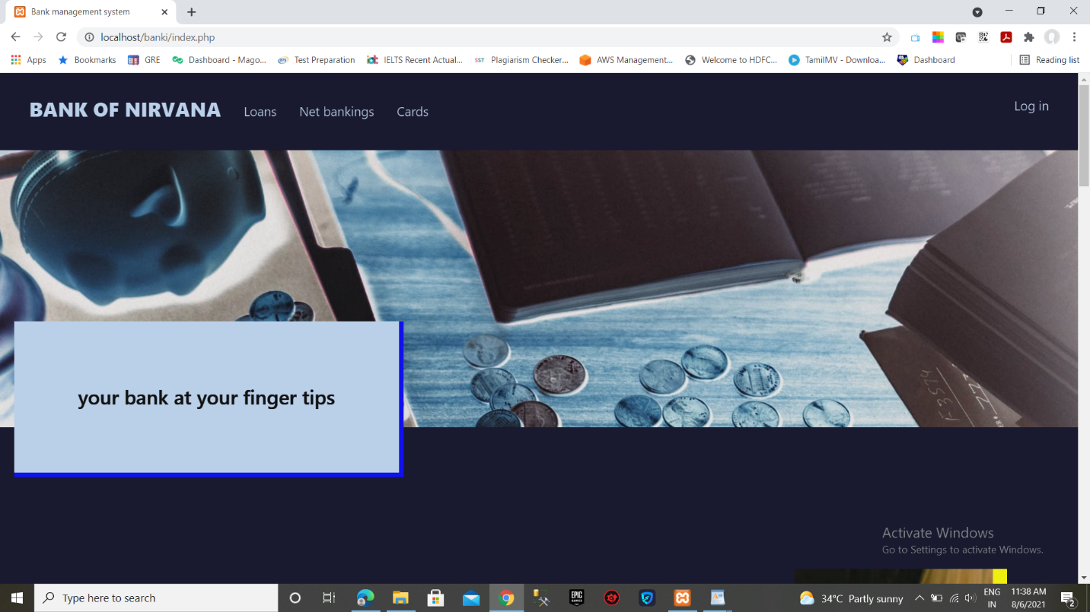

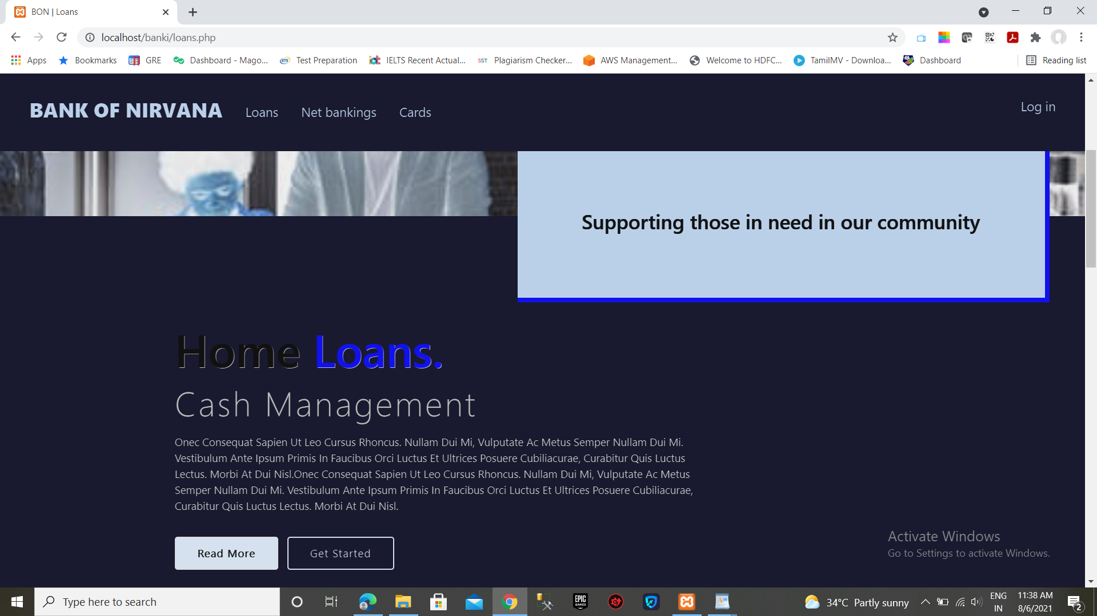

**Cards**

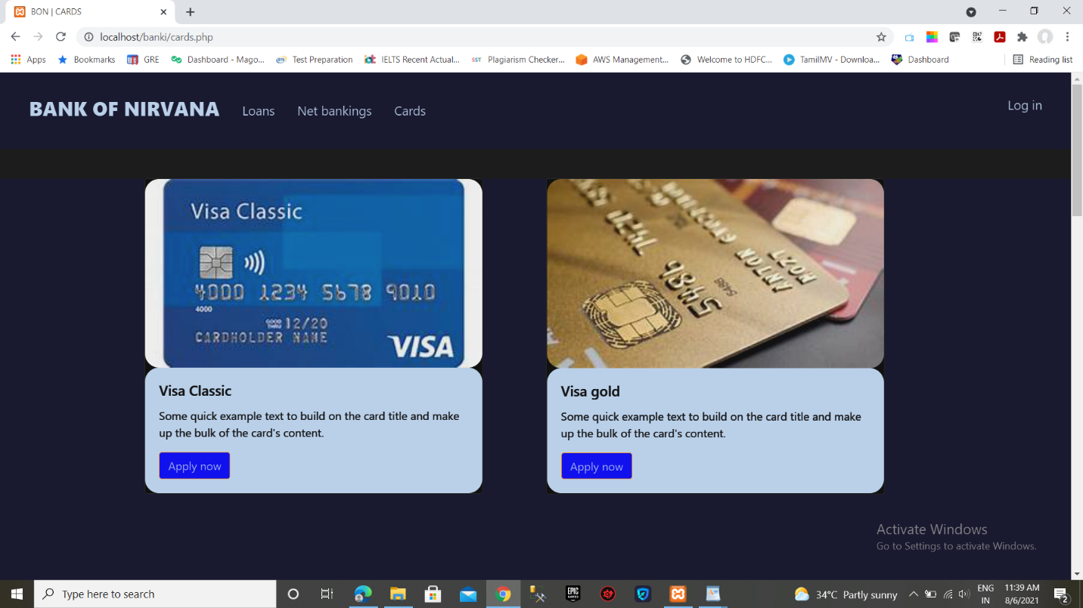

**Loans**

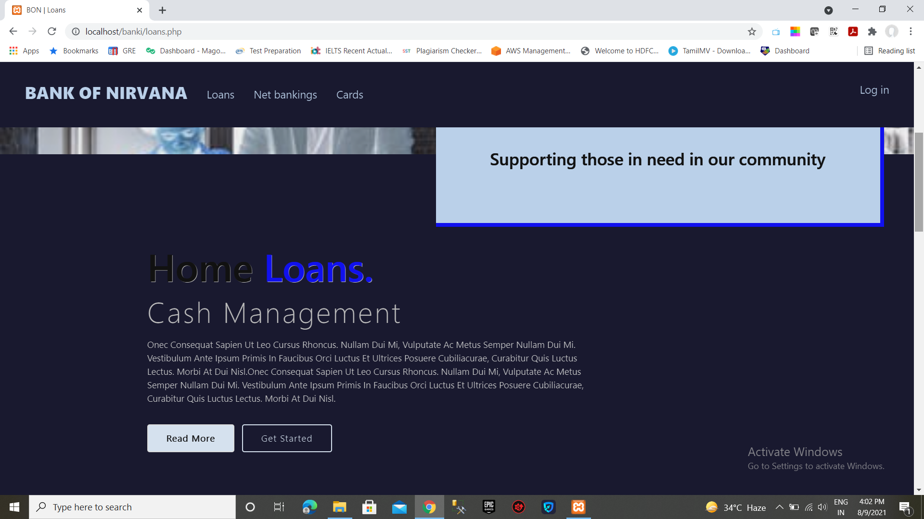

**Net banking**

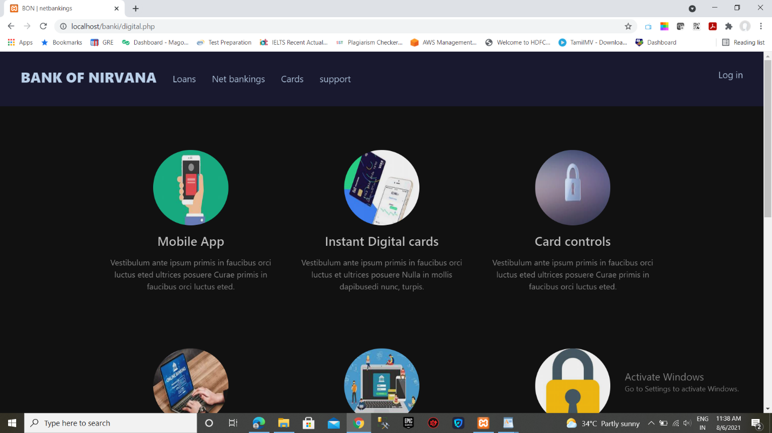

**Login page**

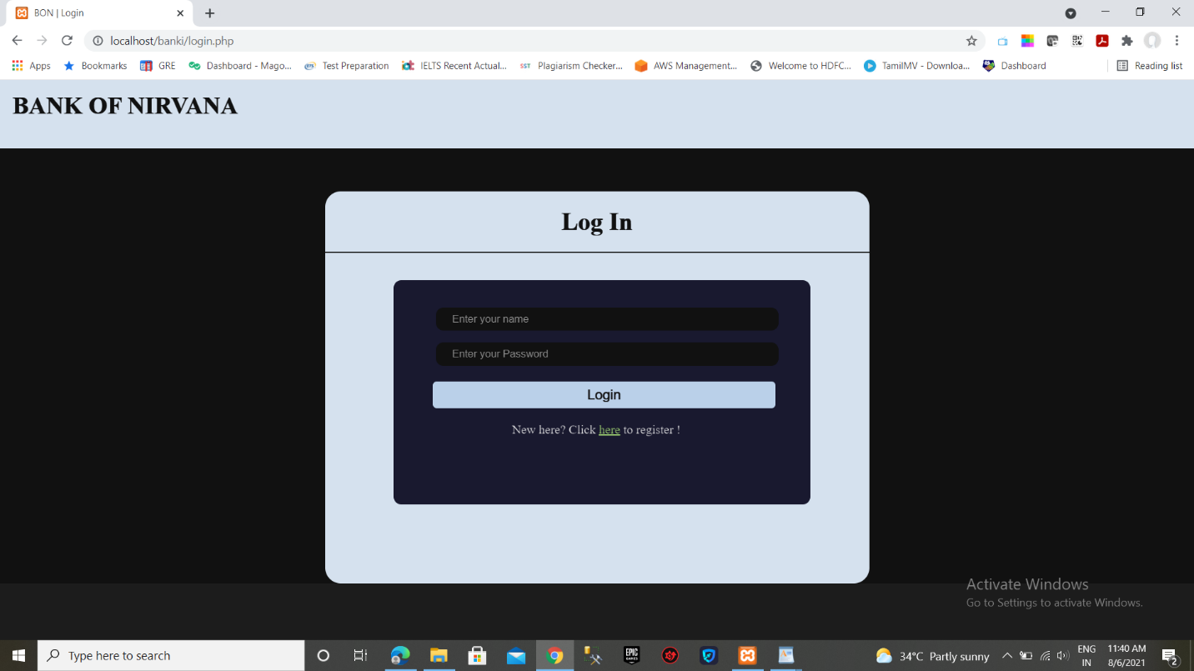

**Sign Up page**

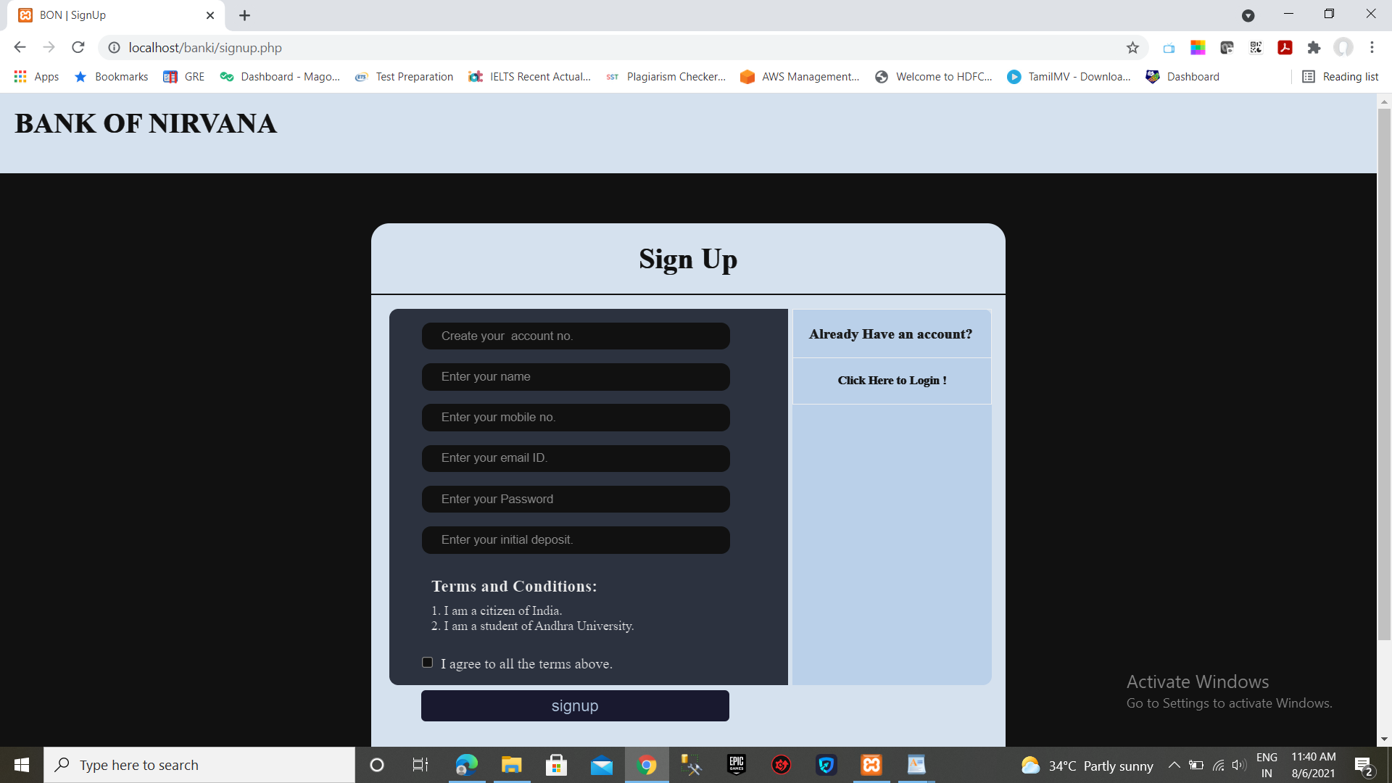

**Transactions**

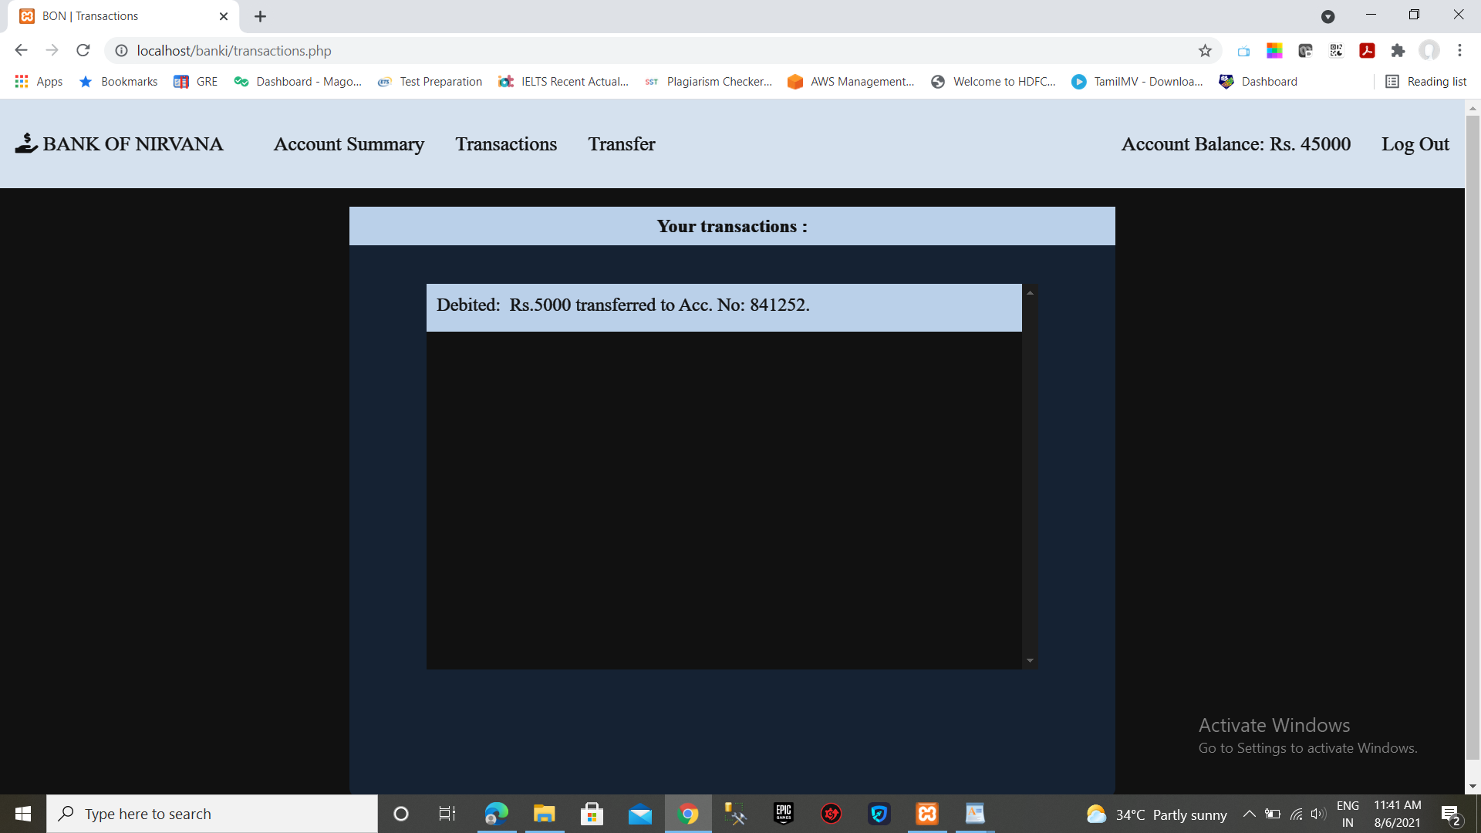

**Account Summary**

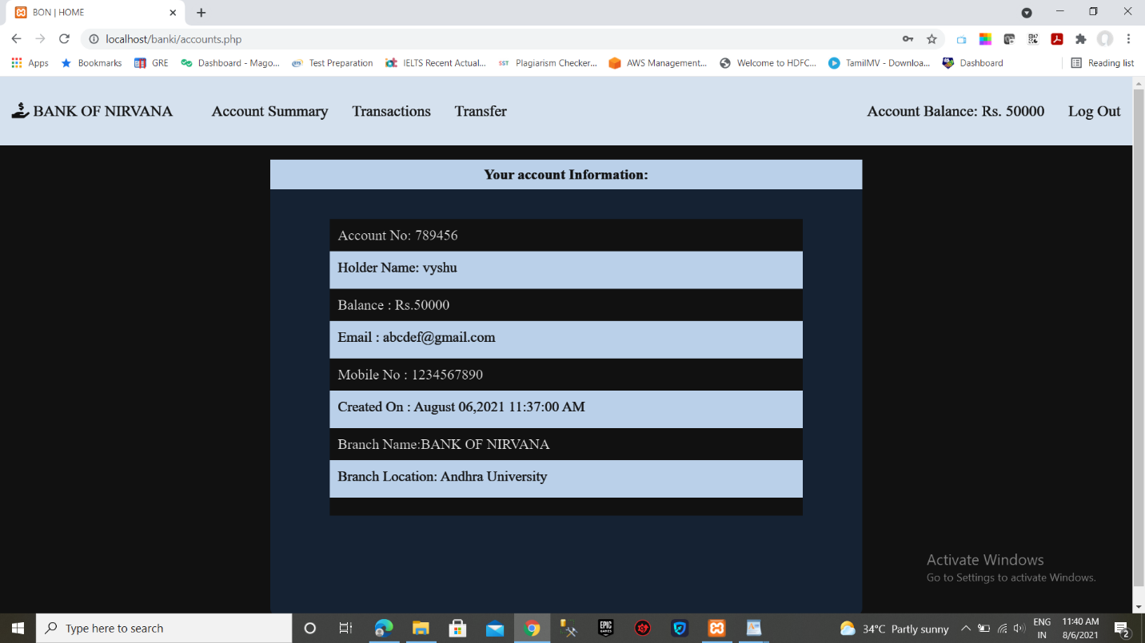

**Transfers**

